**Ansible for Windows 10**

How to install ansible in windows

Step 1: – first all of you require enable **Windows Subsystem for Linux** in Windows 10.

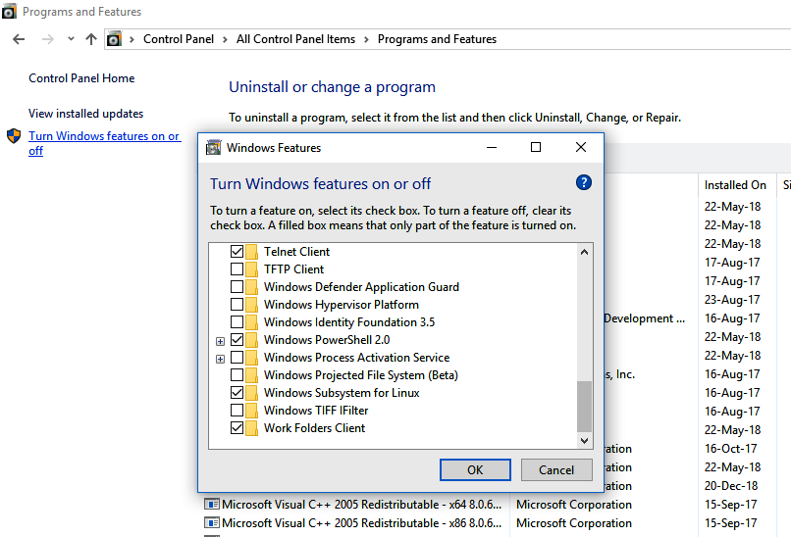Go to Control Panel ->Programs and Features ->select **Windows Subsystem for Linux** option and OK, and Restart PC.

Step 2:- click Window key on keyboard the type **bash run command** and double click than open bellow

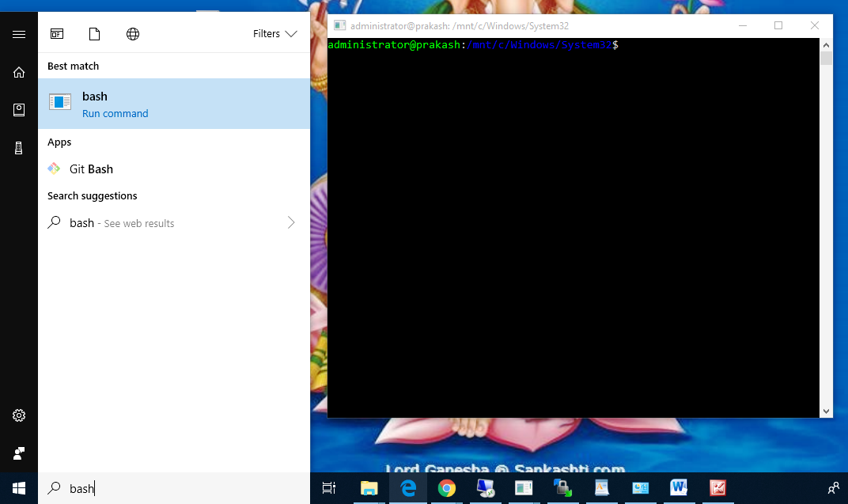 Windows

Step 3: type command sudo **apt-get install software-properties-common** and enter (**wait for process**)

Step 4: type command sudo **apt-add-repository ppa:ansible/ansible** (**wait for process**)

Step 5: type command sudo **apt-get update** (**wait for process**)

Step 6: type Command sudo apt-get installs ansible (**wait for process**)

Do you want to continue? **Yes** all time.

Step 7: ansible is installed completely finish

Step 8: type command **ansible --version** and show you ansible version.

Step 9: type command **pip install "pywinrm>=0.3.0"** (install WinRM Service )

**Command Summary**

[**Install latest ansible on a Ubuntu Linux based distro**](https://www.cyberciti.biz/faq/how-to-install-and-configure-latest-version-of-ansible-on-ubuntu-linux/)

Type the following [apt-get command](https://www.cyberciti.biz/tips/linux-debian-package-management-cheat-sheet.html):  
$ sudo apt-get update  
$ sudo apt-get install software-properties-common  
$ sudo apt-add-repository ppa:ansible/ansible  
$ sudo apt-get update  
$ sudo apt-get install ansible